(Approx. 356 words)

Another Day. Another Scam. Don’t Fall for it.
By Kurt Jefferson, Editor, Central Kentucky Computer Society
https://newsite.ckcs.org/
lextown77 (@) mymetronet.net

I wonder how many Americans this very minute are being taken for a ride and giving away their personal information to a criminal. You might be surprised. At all hours of the day, people are turning over credit card numbers and more to thugs.

As Aura writes, “When Mary Anne May received a text from UPS on the day after Mother’s Day, she assumed a family member sent her a gift that she wasn’t home to receive. But when she clicked on the link in the text to reschedule the delivery, and was
asked for her credit card number, she started to get suspicious.

While Mary Anne’s caution was well-founded, millions of Americans have fallen victim to package delivery scams like this one.”

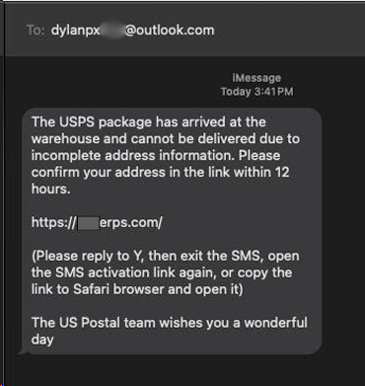
In recent days, I’ve received a number of bogus text messages on my phone. I simply report them as junk and delete them.

Here’s an example. The bogus text message alerts me that the US Postal Service is holding a package at its “warehouse” and cannot deliver it because it lacks complete street address details. Look who supposedly sent the text. It’s from a guy named Dylan. This is the first red flag. Think about it. USPS will never text you using a bogus email address starting with “dylan.”

Second, the letter carrier has been delivering mail and Amazon packages to my house for years. USPS doesn’t have my address? Then who’s the guy who’s been delivering junk mail to my mailbox for years?

Third, the USPS doesn’t have “warehouses.” They don’t use that phrase. The USPS has distribution centers. And I’m very glad to know that the bogus US Postal team is wishing me a wonderful day! Finally, the USPS doesn’t use bogus web addresses, as
shown in the text. A legitimate message would read usps.com or something similar.

If I click on the link shown in the text, I’ll get a website where I can easily enter my credit card number to be scammed by Dylan or whoever is trying to turn me into a victim. Hey Dylan, have a wonderful day!

